AIM: To create an application using Kotlin to perform basic calculator operations like addition, subtraction, multiplication and deletion.

CODE:

MainActivity.kt

package com.example.simplecalculator  
  
import android.os.Bundle  
import android.widget.Toast  
import androidx.activity.enableEdgeToEdge  
import androidx.appcompat.app.AppCompatActivity  
import androidx.core.view.ViewCompat  
import androidx.core.view.WindowInsetsCompat  
import com.example.simplecalculator.databinding.ActivityMainBinding  
  
class MainActivity : AppCompatActivity() {  
 private lateinit var binding : ActivityMainBinding  
 override fun onCreate(savedInstanceState: Bundle?) {  
 super.onCreate(savedInstanceState)  
  
 binding=ActivityMainBinding.inflate(*layoutInflater*)  
 setContentView(binding.*root*)  
  
 binding.addbutton.setOnClickListener **{** calculatelogic(1) **}** binding.subtractbutton.setOnClickListener **{** calculatelogic(2) **}** binding.multiplybutton.setOnClickListener **{** calculatelogic(3) **}** binding.divisionbutton.setOnClickListener **{** calculatelogic(4) **}** }  
 fun calculatelogic(operation : Int){  
 var firstNumberText=binding.firstnumber.*text*.toString()  
 var secondNumberText=binding.secondnumber.*text*.toString()  
  
 if(firstNumberText.*isEmpty*()||secondNumberText.*isEmpty*())  
 {  
 Toast.makeText(this,"Fill first and second number",Toast.*LENGTH_SHORT*).show()  
 return  
  
 }  
 var firstNumber=firstNumberText.*toIntOrNull*()  
 var secondNumber=secondNumberText.*toIntOrNull*()  
 if(firstNumber != null && secondNumber!=null){  
 var result=when(operation){  
 1 -> firstNumber+secondNumber  
 2 -> firstNumber-secondNumber  
 3 -> firstNumber*secondNumber  
 4 -> if(secondNumber!=0)firstNumber/secondNumber else{  
 Toast.makeText(this,"You cannot divide a number by 0",Toast.*LENGTH_SHORT*).show()  
 return  
 }  
 else -> 0  
  
 }  
 binding.resultText.*text*=result.toString()  
 }  
 else{  
 Toast.makeText(this, "Please add only numbers",Toast.*LENGTH_SHORT*).show()  
 }  
  
 }  
}

activity_main.xml

<?xml version="1.0" encoding="utf-8"?>  
<androidx.constraintlayout.widget.ConstraintLayout xmlns:android="http://schemas.android.com/apk/res/android"  
 xmlns:app="http://schemas.android.com/apk/res-auto"  
 xmlns:tools="http://schemas.android.com/tools"  
 android:id="@+id/main"  
 android:layout_width="match_parent"  
 android:layout_height="match_parent"  
 tools:context=".MainActivity">  
  
 <EditText  
 android:id="@+id/firstnumber"  
 android:layout_width="match_parent"  
 android:layout_height="wrap_content"  
 android:hint="First Number"  
 android:layout_marginTop="100dp"  
 android:layout_marginStart="50dp"  
 android:layout_marginEnd="50dp"  
 app:layout_constraintStart_toStartOf="parent"  
 app:layout_constraintEnd_toEndOf="parent"  
 app:layout_constraintTop_toTopOf="parent"  
 />  
  
  
 <EditText  
 android:id="@+id/secondnumber"  
 android:layout_width="match_parent"  
 android:layout_height="wrap_content"  
 android:hint="Second Number"  
 android:layout_marginTop="20dp"  
 android:layout_marginStart="50dp"  
 android:layout_marginEnd="50dp"  
 app:layout_constraintStart_toStartOf="parent"  
 app:layout_constraintEnd_toEndOf="parent"  
 app:layout_constraintTop_toBottomOf="@id/firstnumber"  
 />  
  
 <GridLayout  
 android:id="@+id/operationLayout"  
 android:layout_width="wrap_content"  
 android:layout_height="wrap_content"  
 android:layout_marginTop="64dp"  
 app:layout_constraintEnd_toEndOf="parent"  
 app:layout_constraintHorizontal_bias="0.353"  
 app:layout_constraintStart_toStartOf="parent"  
 app:layout_constraintTop_toBottomOf="@id/secondnumber">  
  
  
 <Button  
 android:id="@+id/addbutton"  
 android:layout_width="100dp"  
 android:layout_height="wrap_content"  
 android:layout_row="0"  
 android:layout_column="0"  
 android:layout_marginStart="60dp"  
 android:text="+"  
 android:textSize="30sp" />  
  
 <Button  
 android:id="@+id/subtractbutton"  
 android:layout_width="100dp"  
 android:layout_height="wrap_content"  
 android:layout_row="0"  
 android:layout_column="1"  
 android:layout_marginStart="20dp"  
 android:text="-"  
 android:textSize="30sp" />  
  
 <Button  
 android:id="@+id/multiplybutton"  
 android:layout_width="100dp"  
 android:layout_height="wrap_content"  
 android:layout_row="1"  
 android:layout_column="0"  
 android:layout_marginStart="60dp"  
 android:layout_marginTop="30dp"  
 android:text="x"  
 android:textSize="30sp" />  
  
 <Button  
 android:id="@+id/divisionbutton"  
 android:layout_width="100dp"  
 android:layout_height="wrap_content"  
 android:layout_row="1"  
 android:layout_column="1"  
 android:layout_marginStart="20dp"  
 android:layout_marginTop="30dp"  
 android:text="/"  
 android:textSize="30sp"/>  
  
 </GridLayout>  
  
 <TextView  
 android:id="@+id/resultText"  
 android:layout_width="wrap_content"  
 android:layout_height="wrap_content"  
 android:text="Result: "  
 android:textSize="40sp"  
 android:textStyle="bold"  
 app:layout_constraintStart_toStartOf="parent"  
 app:layout_constraintEnd_toEndOf="parent"  
 app:layout_constraintBottom_toBottomOf="parent"  
 app:layout_constraintTop_toBottomOf="@id/operationLayout"  
 />  
  
  
</androidx.constraintlayout.widget.ConstraintLayout>

OUTPUT:

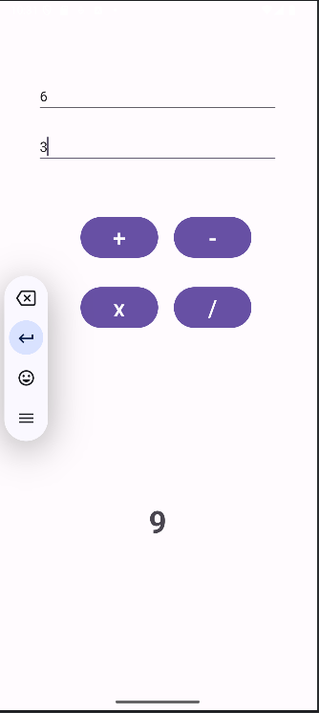

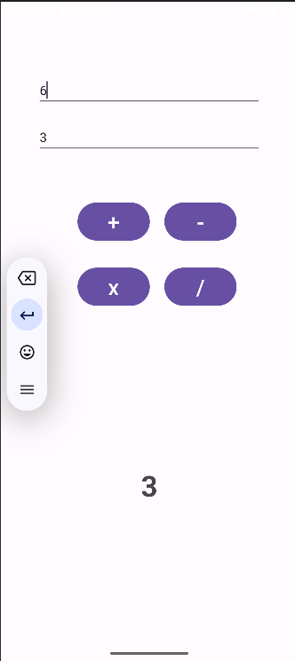

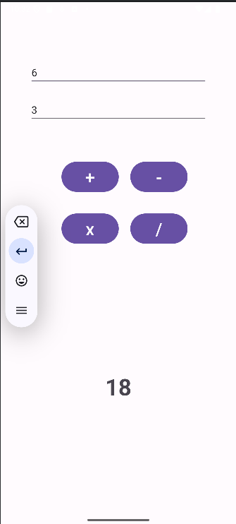

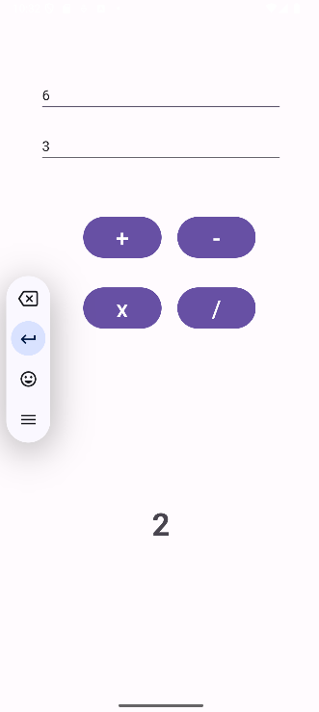

Result: APP SUCCESSFULLY DONE.